Good morning, Owls and Robins,

Writing

Today, we would like you to write a summary of our autumn term. Try to include 3 or 4 things from all of the fun learning we have done so far, which has included:
- Our ‘aeroplane’ flight
- Learning all about Paddington
- Mrs Card making marmalade sandwiches
- Using the big equipment in PE
- Superhero day
- Creating dragons and writing music for them
- Using the computers to make posters about Florence and Mary.
These are just a few things you could talk about. What has been your favourite thing so far?
You should write in the past tense because it is about things which have already happened. This means that our verbs (action words) need to be in the past tense. Can you remember the different rules we looked at? Sometimes we just add -ed (like climbed), sometimes we have to double a letter before we add -ed (like hopped), and some verbs change completely (like eat becomes ate).
You should also try and include some of the conjunctions we have learned this half term.
Co-ordinating conjunctions are used to join 2 clauses (separate sentences) together – these include and, but, or and so.
For example: On the plane I sat next to Jim and I listened to the safety announcement
Sub-ordinating conjunctions are used to join a main clause and some additional information which would not make sense on its own – we have used because, when, that, and if. Remember, the subordinate clause can usually come at the beginning or the end of the sentence,
For example: When the plane took off, I felt so excited!
I felt so excited when the plane took off!

Maths

In Maths we have been learning to add and subtract using a number line or using diennes. We sent a sheet home recently showing grown ups how we have been doing this in school, so you can use this to help you if you need it.

Today we have found you some 2 step problems to try. These need you to both add and subtract to find the answer, so you might need to do 2 number lines for each question.
Here is an example which I have done for you:

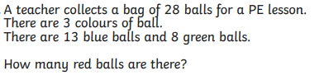

13 blue + 8 green = 21 blue and green balls.

28 balls – 21 blue and green balls = 7 red balls.

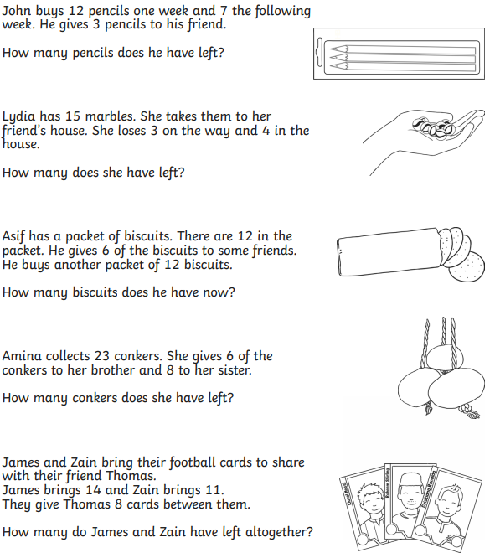
Now have a go at some of these:

Reading:

Please spend some time reading, either to an adult or to yourself.

Spelling:

Please practise your spellings of the /u/ sound spelt ‘o’
These can be found on Google Classroom.

We hope to see you all tomorrow.

From Mrs Young and Miss Cook.

